Admin side: only the one with registered password can view it

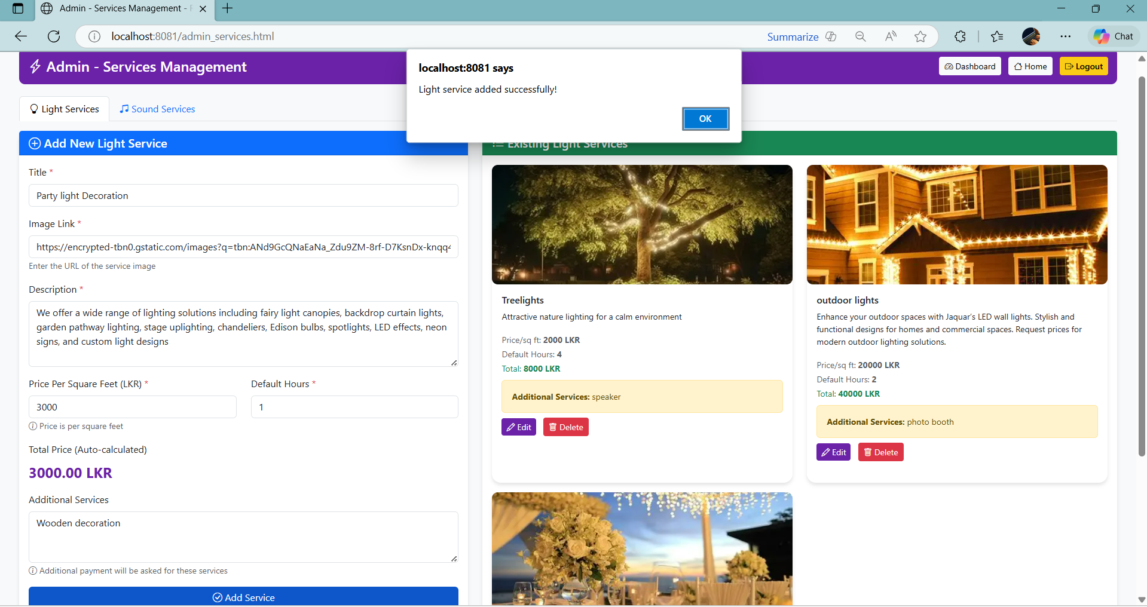

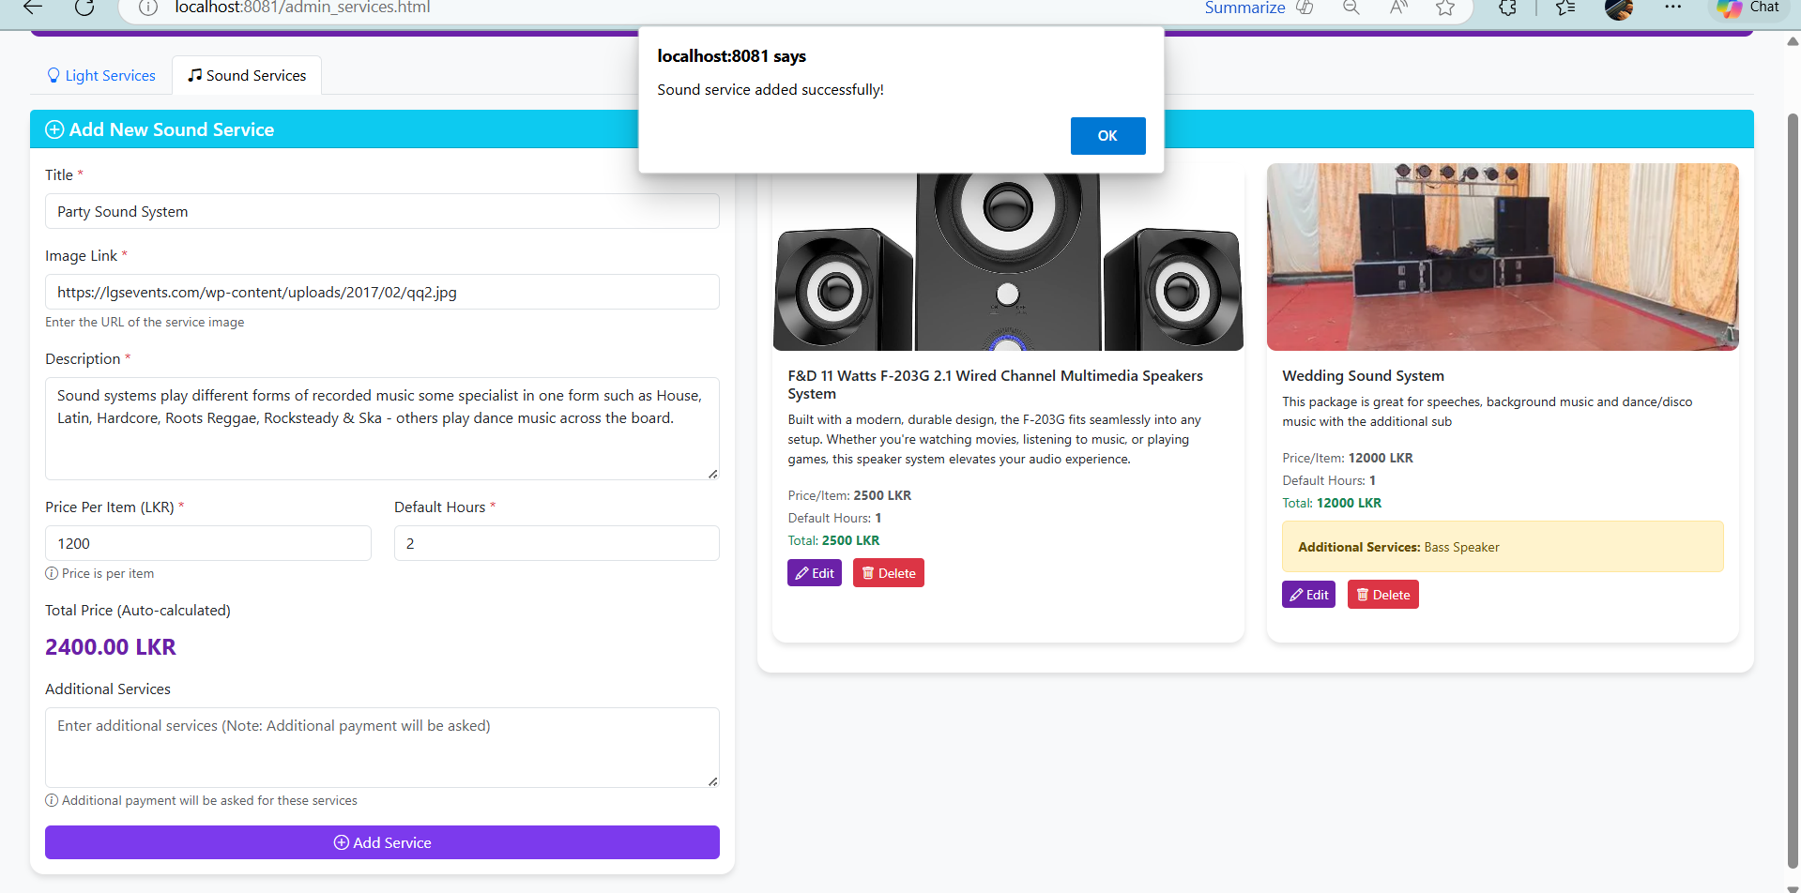

Customer Side: Anyone on the internet can see



